Monthly Program Committee

CHAIRMAN – VICE DIRECTOR
The Old Guard Vice Director serves as the Chairman of the twelve Monthly Program Chairmen in his year of office. He appoints a chairman for each month, starting in July of the year he is Vice Director, and ending with June of the following year. The roster of MPCs should be completed by end of December.
In the winter, he chairs an informational meeting with the Monthly Program Chairmen to cover responsibilities, duties, and the policies and procedures to be followed (see below). He draws their attention to the availability of the Blue Book on the Summit Old Guard website. He provides them with the forms and other materials necessary to exercise their responsibilities.
He guides the MPCs throughout the year and periodically updates all on status of future programs.
To handle the possibility of a speaker canceling at the last minute, he has arrangements for least one back-up speaker (usually an Old Guard member) or a back-up program.
DUTIES – MONTHLY PROGRAM CHAIRMAN
Recruit Speakers. The principal role of the Monthly Program Chairman is to provide and host programs for the regular weekly meetings of the Old Guard. Each Monthly Program Chairman (MPC) plans and oversees the series of programs for the meetings in his assigned month. He should select programs that will interest and entertain the Old Guard members.
Politics, Religion, and Sales: Exercise Caution. The Old Guard’s policy is to avoid programs that promote or oppose the election of particular candidates running for political office, or that advocate or oppose particular religious beliefs, or that are primarily a “sales pitch” for the speaker’s products, services, or business. The MPC should advise potential speakers that this is Old Guard policy.
Coordination. The MPC and the Vice Director should communicate with each other as the MPC’s progress with speakers and recruitment evolves so that conflicts, repetitions, and potential controversies are avoided and high-quality speakers are assured.
Following is an illustrative schedule of procedures to be done for a given month of speakers. Details of procedures follow:
To Do | Lead Time
Identify potential speakers | When MPC appointed
Begin recruiting speakers | At least 6 months
Finalize speakers | At least 3 months
Bulletin Data to Bulletin Editor | 2 months
Complete Names of Speakers to Certificates Committee Chairman | 2 months
Press Data to Public Relations & Publicity Chairman | 1 month
Audio & Visual Requirements to Committee Chairmen | 1 month
Prepare to host the speakers & preside over the programs | During the 1 month  in advance
Host the speakers & preside over the program

Suggested Procedures for Monthly Program Chairman
Please accept these suggestions as the product of our experiences. Improve upon them as you wish and make suggestions to the Vice Director; they will be welcome.
- Identify & Recruit Speakers
It is never too early to obtain conformations from speakers. Should you need speaker suggestions, contact the Vice Director who can provide information gathered by him and his predecessors.
Keep the Vice Director informed of your progress in recruiting speakers.
- Finalize Agreements
After obtaining informal agreement with a speaker, send an email or a snail-mail letter that thanks the speaker, confirms the date, suggests visiting our website www.summitoldguard.org , and attaches or encloses the “Information for Speakers” sheet and the “Speaker Information” form.
After the “Speaker Information” form is returned, review it for completeness to meet the two-month and one-month requirements below. Obtain updates if required.
- Bulletin & Certificate Data
.Two-month Deadline. On or before the first meeting of the month, 2 months prior to your month, provide to the Bulletin chairman the date, title of talk, speaker’s name, association, and a one or two sentence description of every program for the Bulletin preview section.
Also send this material to the Certificates Committee Chair who needs exact names to inscribe the Certificates of Appreciation.
Send copies of information to the Vice Director.
- Publicity Data & Audio-Visual Requirements
One-month Deadline. On or before the first meeting of the month prior to your month, for every program provide to the Public Relations Committee Chair the date, title of talk, speaker’s name, association, an extended abstract, biographical information that can be provided to the media to publicize the program, and a photograph of the speaker(s) (if available).
Also, determine what audio, visual aids, displays and other equipment the speaker will bring and what Old Guard equipment is needed. Send the information to the two Audio & Visual Aids Committee chairmen so that adequate microphone(s), screen, projector, computer, etc. are available.
Send copies of information to the Vice Director.
- Prepare To Host The Speaker
For each female speaker, arrange to have a white orchid at our meeting. Hall’s Florist, 700 Springfield Avenue, Berkeley Heights, NJ 07922, phone number (908) 665-0331, generally provides orchids to the Old Guard at no cost (one per month). Notify Hall’s in advance and pick up the orchid corsage in the morning of the meeting. Otherwise, bill to the Old Guard.
In advance of the meeting, invite the speaker to be our lunch guest. If accepted, ask a few interested members if they would like to go to lunch with the speaker. Experience suggests that the speaker, MPC, “thanker”, and three members make a good size group of six for conversation. Although, speakers are not paid for their presentations, lunch after the meeting shows our appreciation. The Treasurer will reimburse a reasonable cost of the luncheon for the speaker(s) and MPC up to $30.00 per person. Other members pay for their own lunch. Preferably, the chairman pays the entire bill and collects from the others later. If there are multiple presenters, such as a choral group, the Vice Director should be consulted with respect to an alternative atmosphere.
Make a reservation about a week in advance at a moderately priced restaurant which offers a pleasant atmosphere.
Make specific arrangements to meet and greet the speaker upon arrival. Be sure to .have the speaker’s cellphone number in order to handle last minute emergencies.
Invite the speaker to arrive about 9:30 A.M to allow time for checkout of the audio- visual equipment, P.A. system and lighting arrangements. Remind the speaker that the 40-45-minute program will start at about 10:30 A.M. This will allow time for questions and answers plus our “thank you” before adjournment at 11:30 A.M.
Remember that the program for the last Tuesday of each month includes the Birthday Committee’s ten-minute recognition to our “Birthday Boys”. Advise the speaker that he or she has a short presentation with a total of 45 minutes including Q&A at this meeting.
- Host The Speaker
If the speaker is arriving by car, have the “Reserved for Speaker” parking sign in place at the parking spot (arrange this with the Hospitality Committee). Some MPCs may wish to pick up the speaker elsewhere.
Before meeting the speaker, check that the Certificate of Appreciation is ready and that a bottle of water will be provided.
Escort the speaker to the meeting room. Review the audio and visual arrangements, provide coffee and a name tag, and introduce the speaker to some members. Sit with the speaker for the membership meeting.
- Prepare To Preside Over The Program
Prepare an introduction of the speaker that has biographical information and that is limited to two or three minutes.
In order to relieve yourself of homework for presiding over ceremonies at the end of the program, consider having an Old Guard “thanker” to close the program following the question and answer period. If you decide on this alternative, in advance of the meeting, ask an Old Guard member to be the “thanker” who thanks the speaker, expresses appreciation and understanding of the talk, presents the Orchid Certificate (and orchid to a lady speaker) to the speaker, and leads the Old Guard salute.
Offer guidance to the “thanker” in explaining the “orchid” logo of the Old Guard, so that the presentation is historically correct and not frivolous. For example: “During the first half of the 20th century, Summit was nationally known for orchid hybridizing and production. This reputation led the Old Guard to select the orchid as its logo on this certificate. We express our appreciation to you with this Orchid Certificate”.
Here is a link to a white paper about the history of the orchid in Summit: http://www.summitoldguard.org/OrchidHistory.pdf
- Preside Over The Program
.Preside over the program portion at the meeting and introduce the speaker with personal information, organized in advance and limited to two to three minutes.
Be the moderator during the question and answer session. Discourage statements or personal views (non-questions) by members of the audience. Be sure the wireless mike is used by members asking questions. Tactfully close the Q&A period at 11:25 A.M. by saying: “There is time for one more question”.
Close the program: thank the speaker, express appreciation and understanding of the talk, present the Orchid Certificate (and orchid to a lady speaker) to the speaker with correct historical information, and lead the Old Guard salute.
Note: This formal closure of the meeting helps keep member moral high and promotes our reputation among past and potential speakers.
- Enjoy Lunch & Say Farewell
Escort the speaker(s) to the car, train, or bus
Send letter of appreciation to the speaker on behalf of the Old Guard, signed by the Director or you, as appropriate. Old Guard stationery is available from the Corresponding Secretary, if you wish to use it.
- Relax – You’ve Done A Great Job

Information for Speakers

Information for Speakers
(To be completed by Monthly Program Chairman and given to speaker)
Meeting Venue: Council Chambers in New Providence Municipal Center
360 Elkwood Avenue, New Providence, NJ 07974 (see enclosed map)
Alternative Plan: When a meeting cannot be held in-person, it may be moved online through teleconferencing using this link: https://redoak.org/zoom

Date of talk: _____________ Name of Speaker: ____________________________________
Time of talk: Arrive by 9:30 A.M, meeting starts at 10:00 A.M, talk starts at 10:30 A.M.

Length of talk Forty +/- minutes, conclude by 11:20 A.M. for Q & A Meeting concludes by 11:30 A.M. may use the podium mike, a wireless handheld mike, or headset

Audience: 100+ professional members of the Old Guard and invited guests

Equipment available Computer, Windows 7 with CD/DVD, Power Point
(by request): Laptop projector, remote changer, laser pointer, large projection screen Public Wi-Fi
Video adaptors for guest speaker’s Windows Laptop, MacBook,
smartphone, or HDMI device
Slide projector (Kodak Carousel)
DVD and CD players
VU-graph projector
(In case you intend to bring your own equipment, please advise what you will bring with you and let us know what you will need from us).

Other items requested: ______________________________________ e.g. tables, easel, etc.

Visuals: If possible, use large print and pictures so material can be read in back of room – approx. 50’

Parking: There will be a reserved space for you in the “Visitors Parking” lot directly in front of the entrance door to the Municipal Center

Greetings: You will be met at the entrance to the Municipal Center by:
__________________________________________________________

Old Guard Member Contact: ____________________________________________________

Phone __________________________ Cellphone ____________________________

Email _________________________________________________________________

Summit Area Old Guard – Meeting Place -- Map
New Providence Municipal Center, 360 Elkwood Ave, New Providence NJ 07974

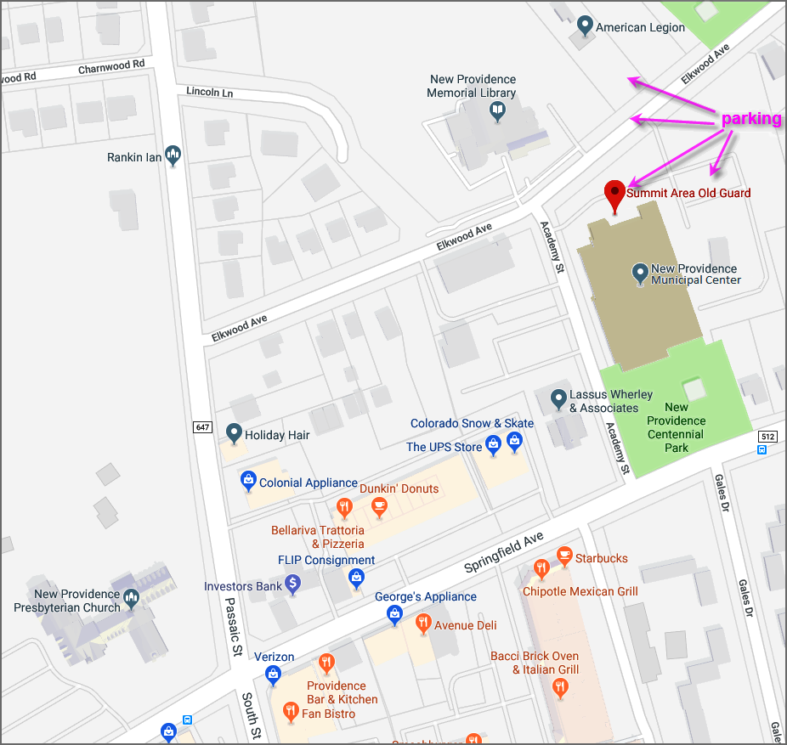

Note: For an active version of this map and for detailed driving directions, see www.summitoldguard.org/Directions.html

Speaker DATA Form
Name of speaker(s):
Address of speaker(s):
Phone number:
Mobile number:
Email:
Title of Talk:
A brief description of the material covered in the talk – suitable for publication in a local paper (continue on back if necessary)

Brief bio (for use in the introduction – continue on back if necessary)

Visual aids requested (e.g. projector, computer):
Other items needed (as a table, etc.):
We publicize talks in Old Guard meetings, in local newspapers, so please fill out the above request for information on your talk. With the speaker’s permission, we like to include a photo of the speaker(s) in the article. If you are willing, please provide me with a photo that can be used in an article in the local paper. If you have one in digital form, don’t hesitate to send the photo to me by email. Otherwise send it to me by surface mail.
Program Chair’s Name:
Address:

Phone (prefer cell):
Email:

